jQuery Study Guide : ASD - Week 1

While watching the videos, take notes on the methods and syntax for jQuery, then

refactor your JavaScript from VFW. The most commonly used jQuery methods needed

to refactor your projects are listed below. Pay special attention to selectors, traversal,

events and manipulation techniques in addition to those methods. For more information,

don’t forget about the jQuery docs at http://docs.jquery.com/

The methods listed in the parentheses below are not an exhaustive list! Spend some

time going through the docs, http://dochub.io/#jquery/ or http://woorkup.com/wp-content/

uploads/2011/12/jQuery-17-Visual-Cheat-Sheet.pdf for a printed cheat sheet.

The jQuery Factory

Using the $ next to open brackets, e.g. $();, is called the factory. It allows us to grab and select elements within the DOM.

Selectors

(single element, parent-child, siblings, multiples, filters)

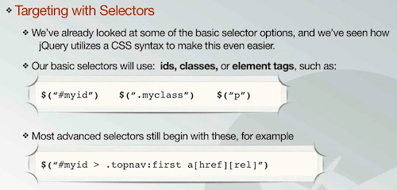

basic selectors:  
$(“#myid”) $(“.myclass”) $(“p”)

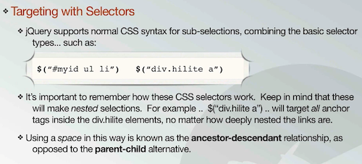

To descend through:  
$(“#myid ul li”) spaces indicate where to go in the code. It will go through the my id and find any ul and find any li inside that ul.

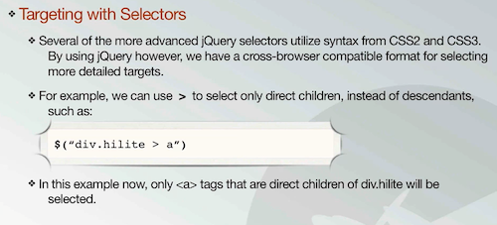

Children and parents:  
Right bracket is children selector.

$(“div.hilite > a”) div.hilite grabs the div with the class of hilite and the > a grabs any child anchors of that div

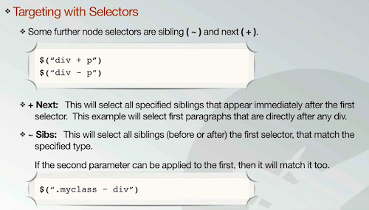

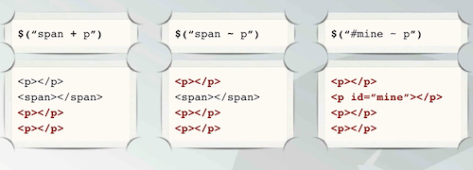

Siblings:  
using + will select all siblings that appear immediately after the first selector.  
ex: $(“div + p”);

Using ~ will select all siblings before or after the selector that match  
ex: $(“div ~ p”);

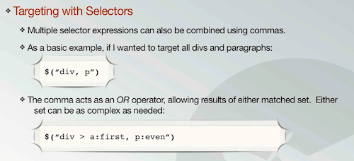

You can select multiple selectors by separating them with commas. The comma acts as an or operator.

Ex. $(“div, p”);

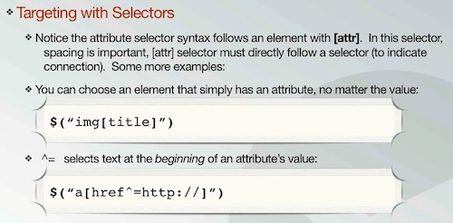

Attribute selector:  
Using square brackets, you can target a specific attribute. Ex. $(“img[title]”)

Using ^ = selects text at the beginning of an attribute’s value:

Ex. $(“a[href=^http://]”)

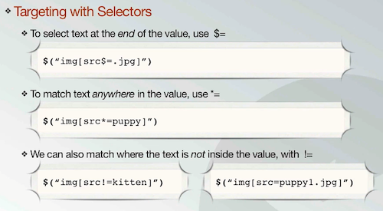

Use $= to select text at the end of an attribute  
ex. $(“img[src$=.jpg]”)

Match text anywhere, use \*=

$(“img[src\*=puppy]”)

match where text is not inside by using !=

$(“img[src!=kitten]”)

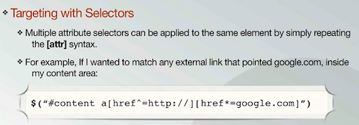

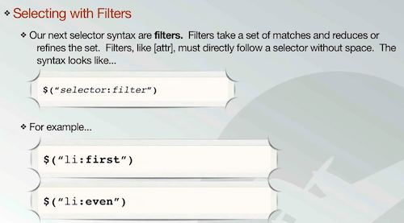

Filters:

Use a colon, no space.   
ex. $(“li:first”) $(“li:even”)

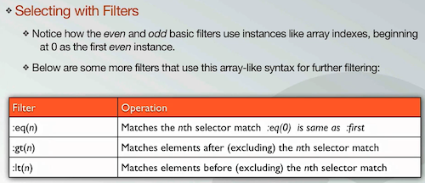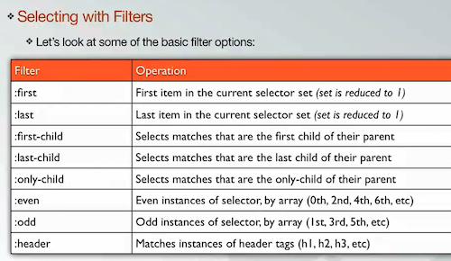

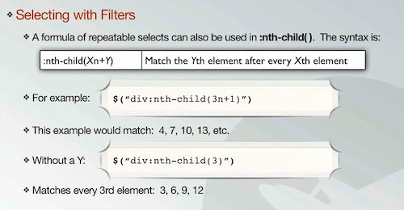

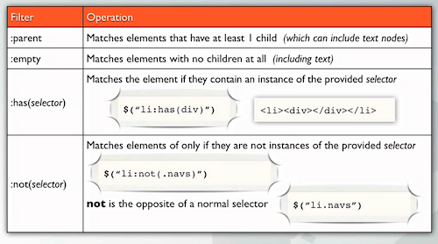

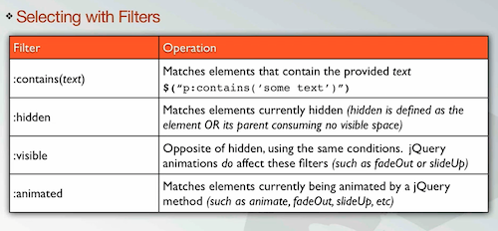

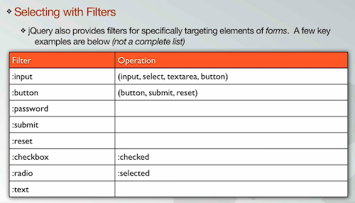

jQuery CSS, Classes and Attributes

(.css .addClass .removeClass .toggleClass .attr)

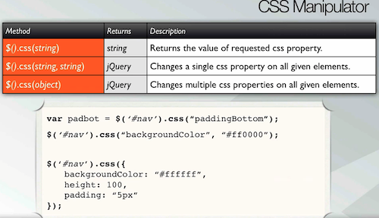

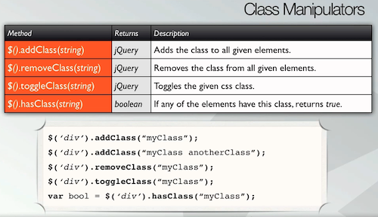

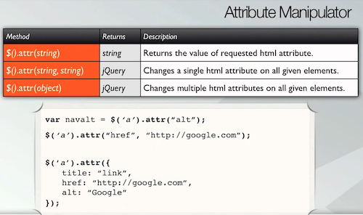

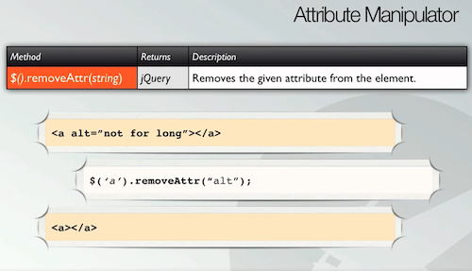

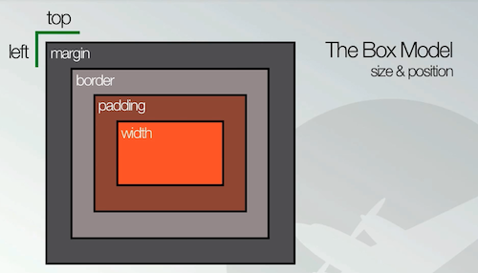

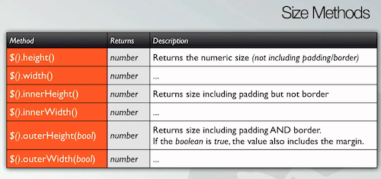

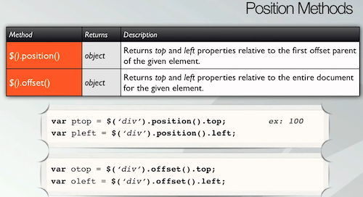

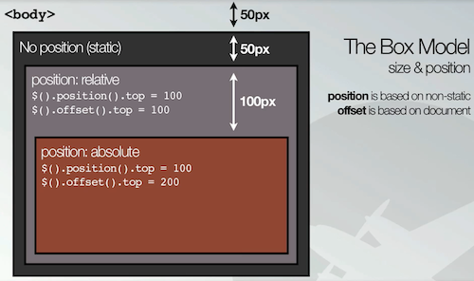

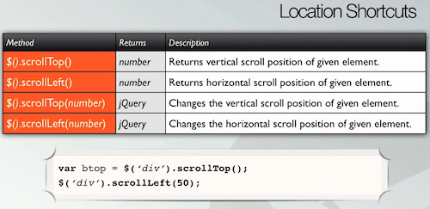

Traversing

(.find .children …and many other filters. May want to write down the ones you think will

be useful for your apps.)

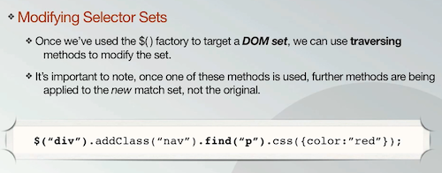

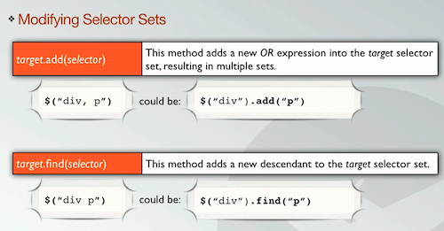

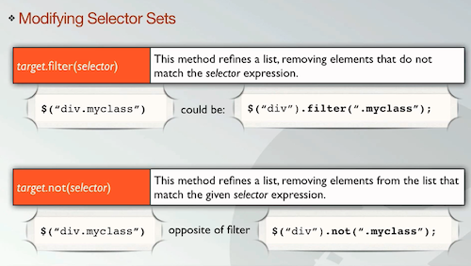

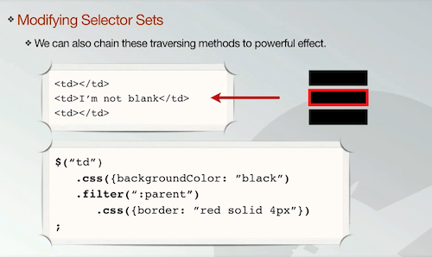

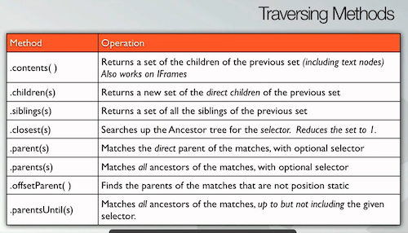

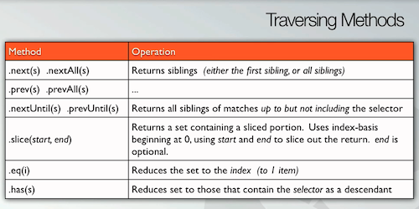

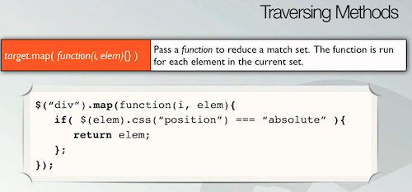

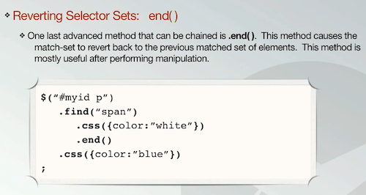

Manipulation

(.html .text .append .appendTo .wrap .insertAfter .empty )

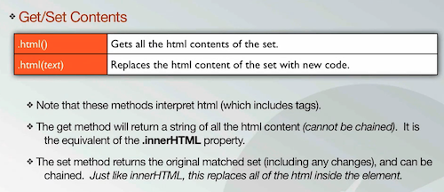

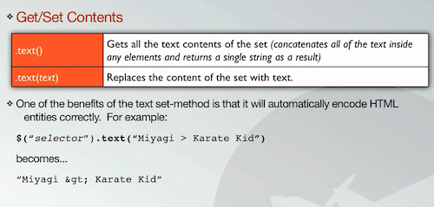

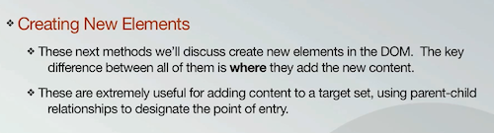

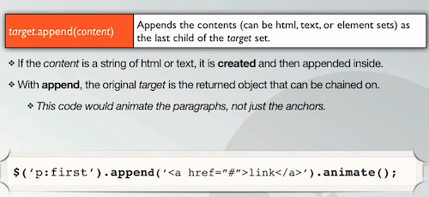

in this example, it would animate the paragraph, not the anchor that was created.

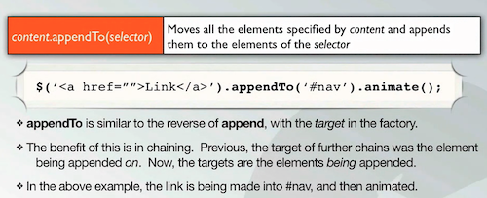

appendTo will allow you to edit the new element you made, append will allow you to edit the entire element that your new element is being appended to.

appendTo can also be used to move existing html elements into a new place.

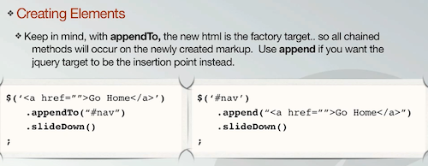

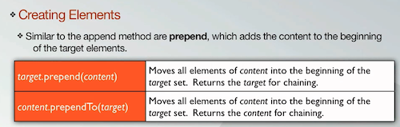

prepend adds to the beginning, append adds to end

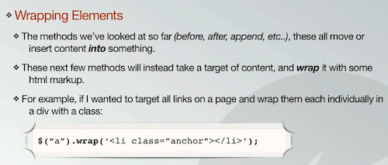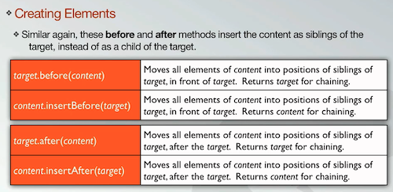

Useful to make siblings instead of children

Used to wrap content in html markup

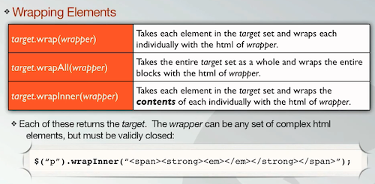

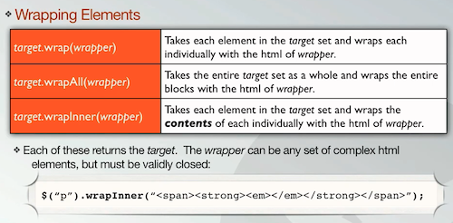

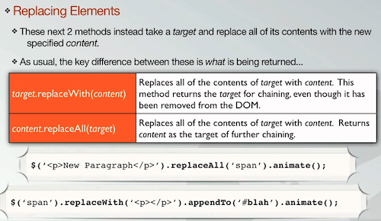

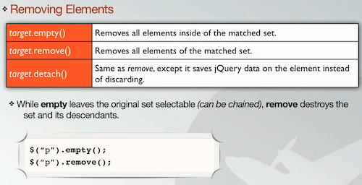

use detach to retain jQuery data instead of destroying everything. Useful for moving.

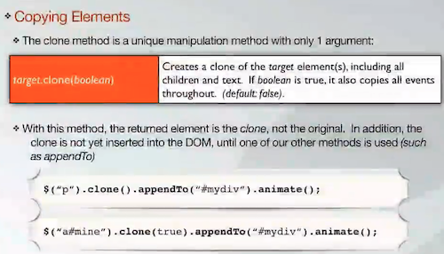

Events

\*\*Note that although the JQM docs and the videos are still using .bind(), jQuery

has been updated to use .on(). I recommend using .on()!

( .on .off e.preventDefault .toggle)

(jQM has its own events - see http://jquerymobile.com/demos/1.1.1/docs/api/events.html

“tap” can be used instead of “click”, but both will work)

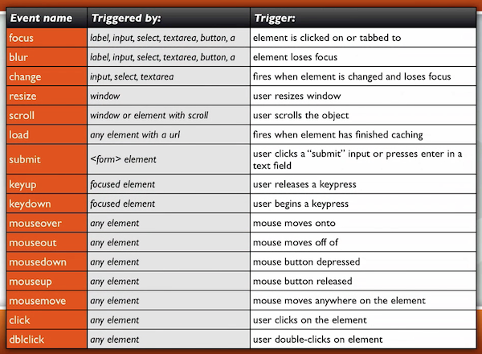

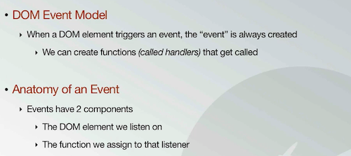

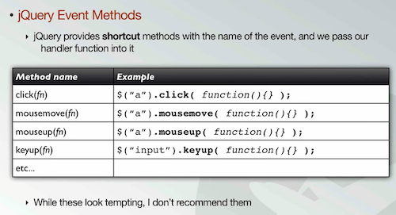

These are not recommended

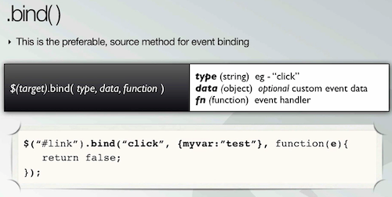

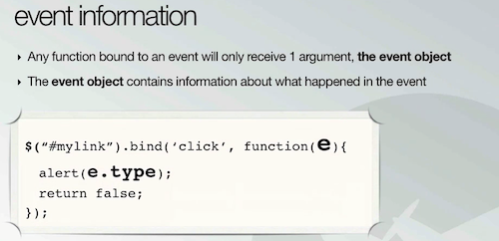

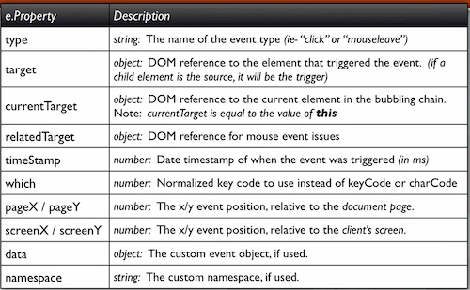

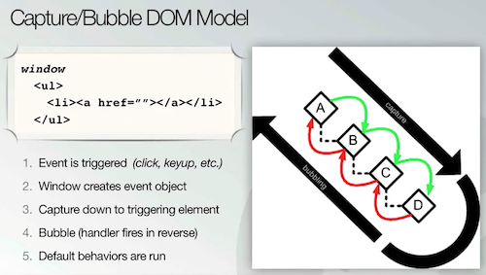

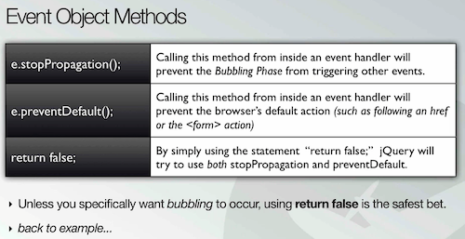

return false should be used almost every time to prevent any unwanted bubbling effects.

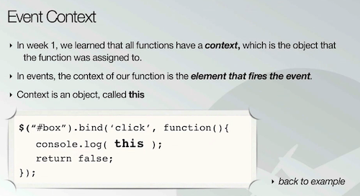

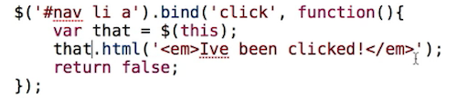

best practice: create a var called that for $(this);

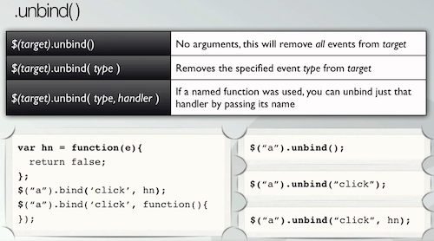

Don’t use mouseover or mouseout, instead use mouseenter and mouseleave

Do not use focus and blur, use instead focusin and focusout

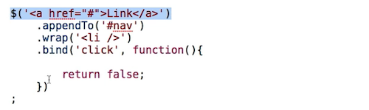

When creating an event, it may be beneficial to wrap a factory element instead in order for the bind/on event to work properly.

ADVANCED EVENTS:  
  
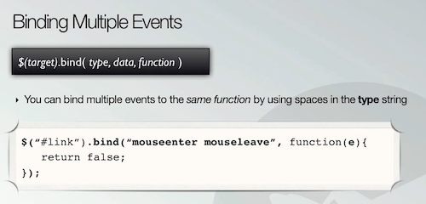

Useful for hover effects. Instead of binding two events, you bind two to one.

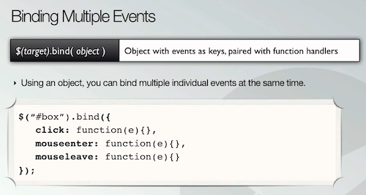

If you use an object literal, you can use multiple events

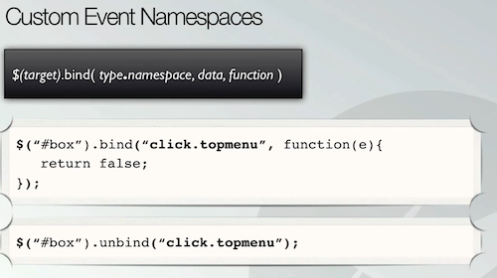

Gives the event a special name. Can be used to unbind specific handlers, as well.

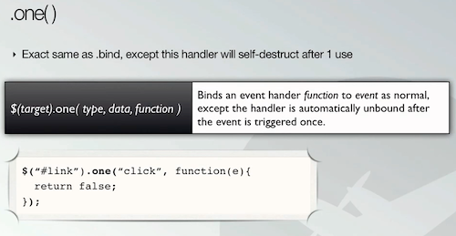

This automatically unbinds itself after first fire.

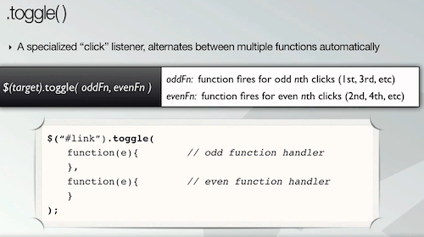

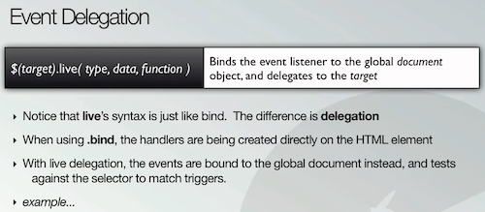

Useful for binding events to new elements that are created. Replaces .bind. The event is bound to the global document object instead of a single element.

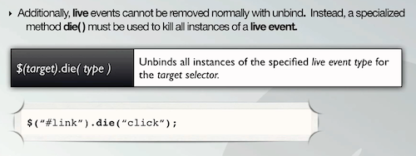

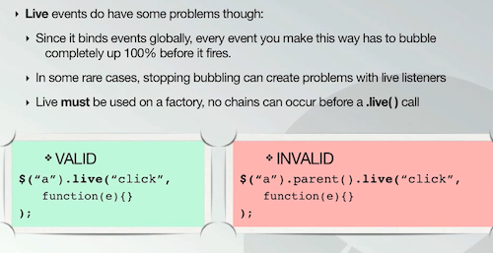

No chains. Eg: no $().parent.live;

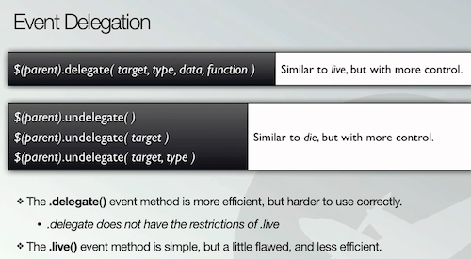

Has more control than live. Doesn’t have the same restrictions.

Tips for success: Document Setup

As Mike says in the video, when using jQuery you want to check to make sure the DOM

is ready to receive the instructions you’re going to give. Normally with jQuery, we check

for this with:

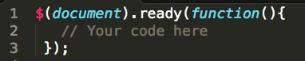

When using jQuery with jQuery Mobile, we want to check to make sure each jQuery

Mobile page is ready when the page is initialized. To do this, you’re going to want to

check for the ‘pageinit’ event before running any code needed for that page:

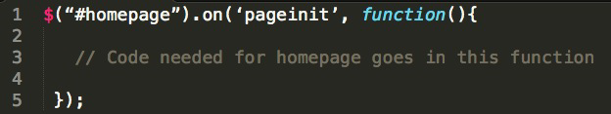

You will need to listen for the pageinit event for each jQM page, and then add the code

needed for each particular page inside of the appropriate pageinit function. For

example, the page that contains your form should have its own pageinit check, with the

JavaScript code needed to handle the form inside:

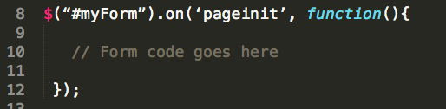

Check out http://jquerymobile.com/demos/1.1.1/docs/api/events.html

for more information.